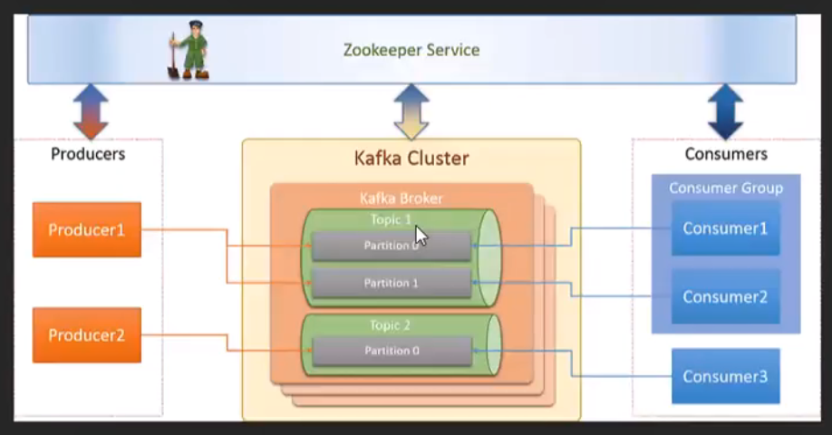

Kafka vs JMS:

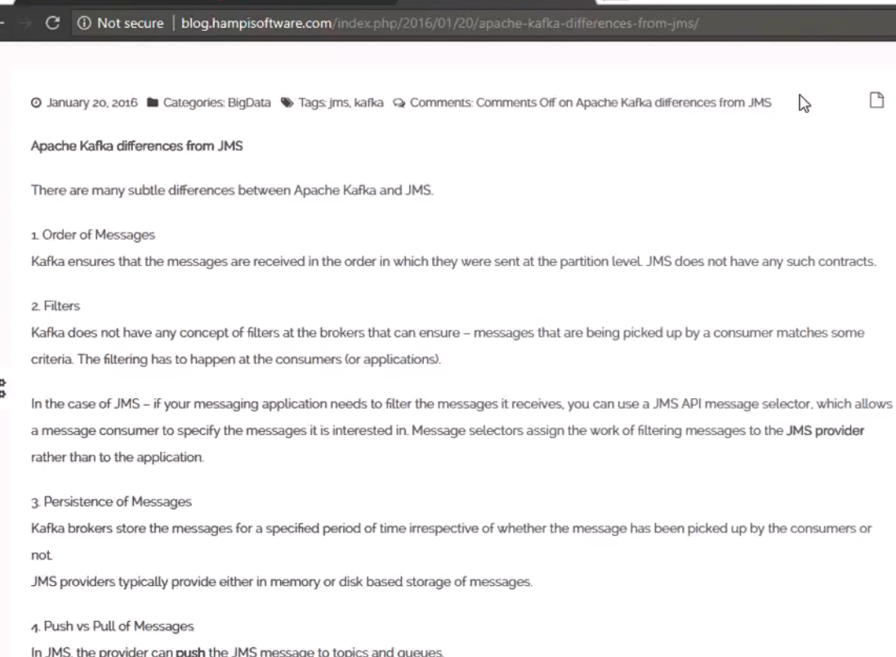

Download Kafka:

<https://kafka.apache.org/downloads>

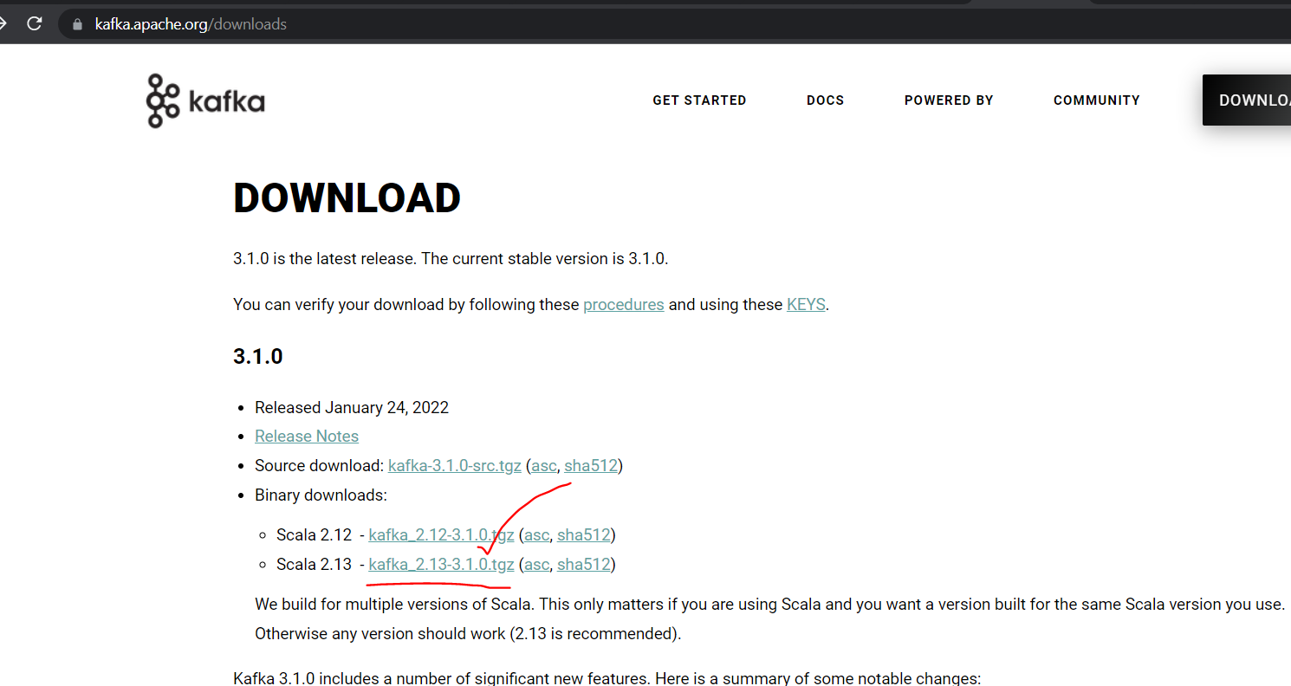

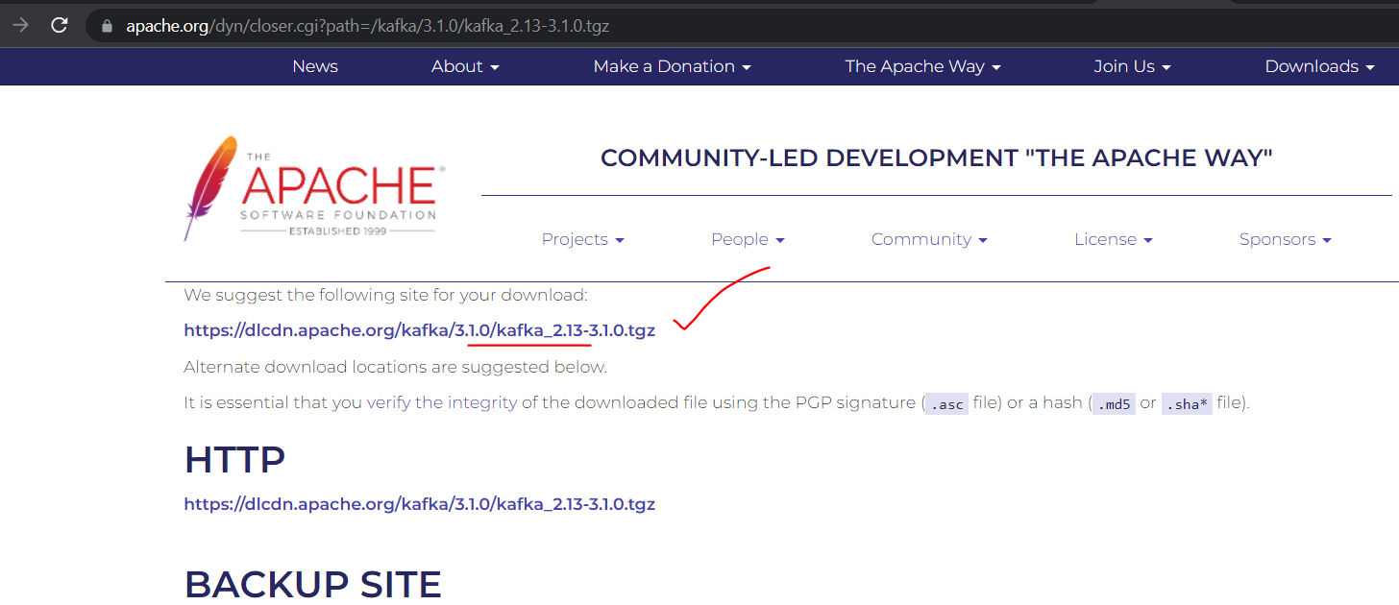

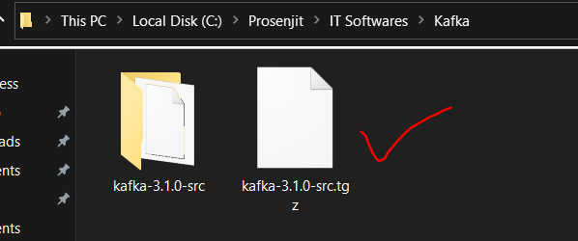

Extract it and rename the folder: (or else we will get error while starting it)

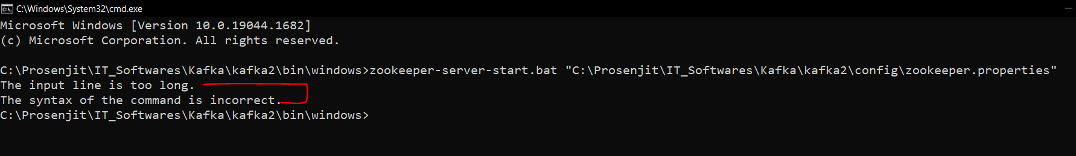

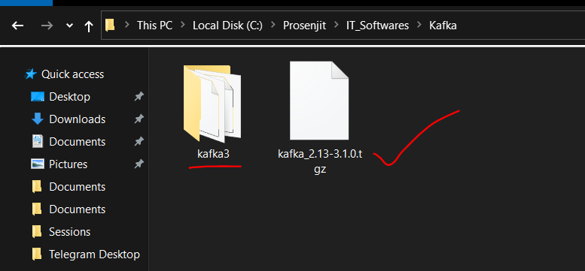

Note:

There is some issue with the latest version of Kafka, unable to create topics. V3.1.0

Reverting to v2.8.1

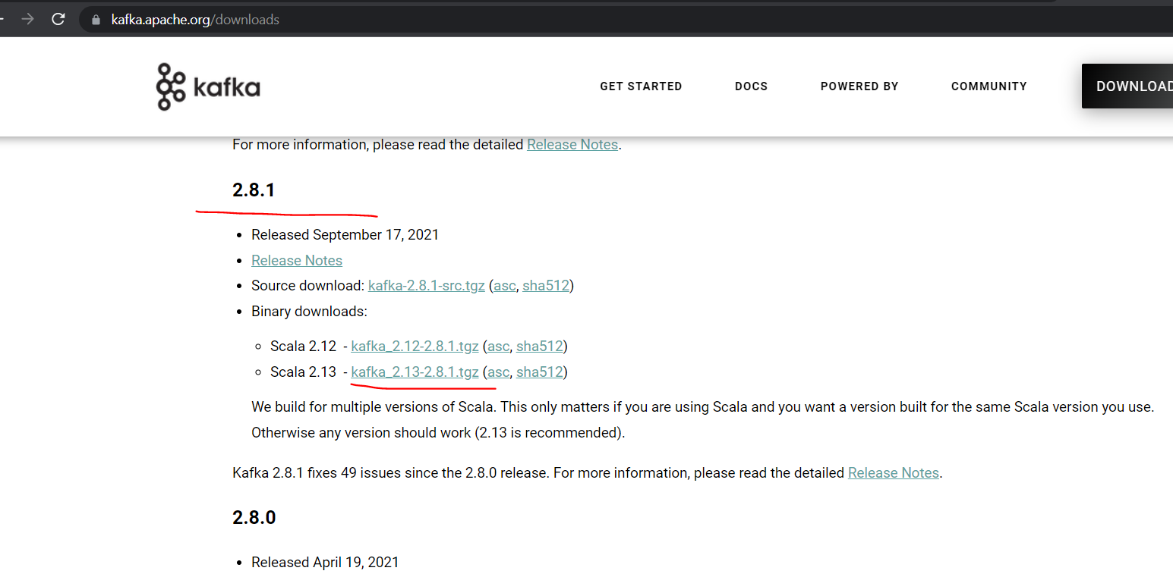

**Open 2 cmd in: (it is not taking even “kafka2” as the folder name)**

**C:\Prosenjit\IT_Softwares\Kafka\kafka\bin\windows**

1. **start zookeeper.start bat file like below**

zookeeper-server-start.bat ./../../config/zookeeper.properties

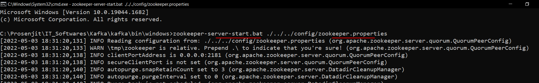

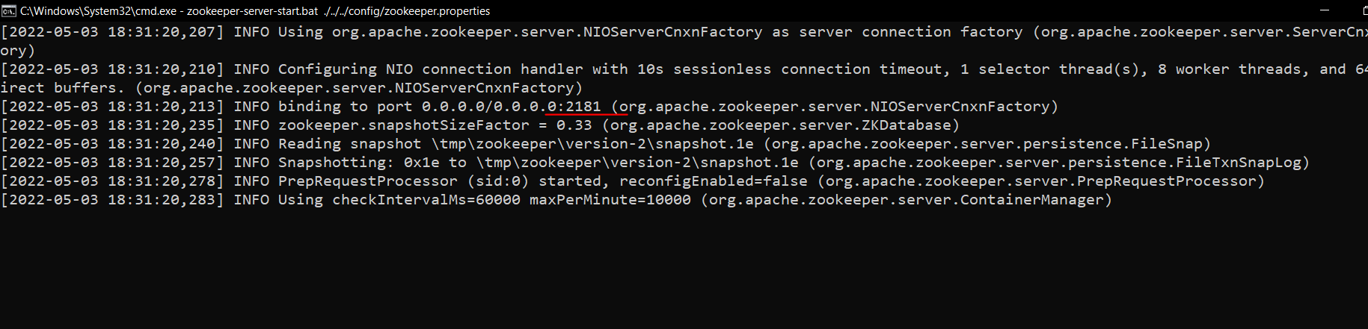

Default port = 2181

1. **start Kafka server**

kafka-server-start.bat ./../../config/server.properties

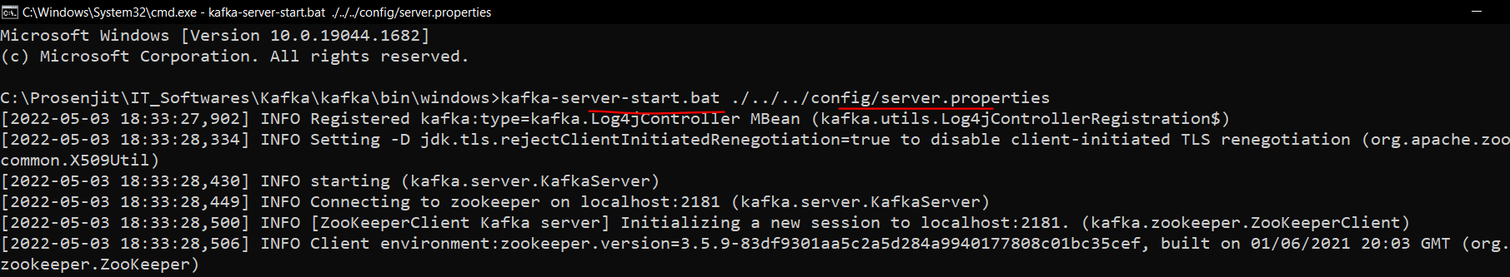

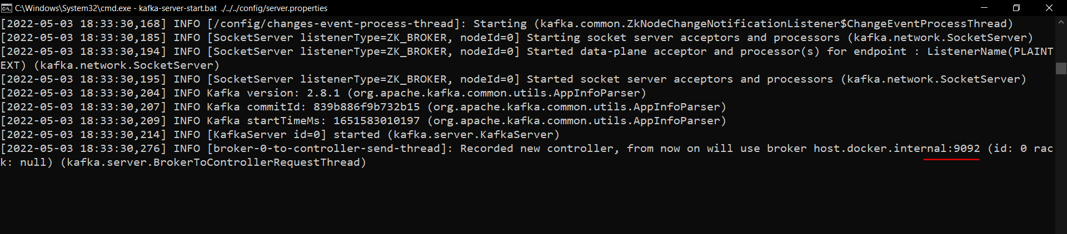

Default port = 9092

Now let’s create a topic:

Open cmd in:

C:\Prosenjit\IT_Softwares\Kafka\kafka\bin\windows

And run:

kafka-topics.bat --create --zookeeper localhost:2181 --replication-factor 1 --partitions 1 -topic demo1topic

Note: here 2081 is the zookeeper port. Here “demo1topic” is the topic name.

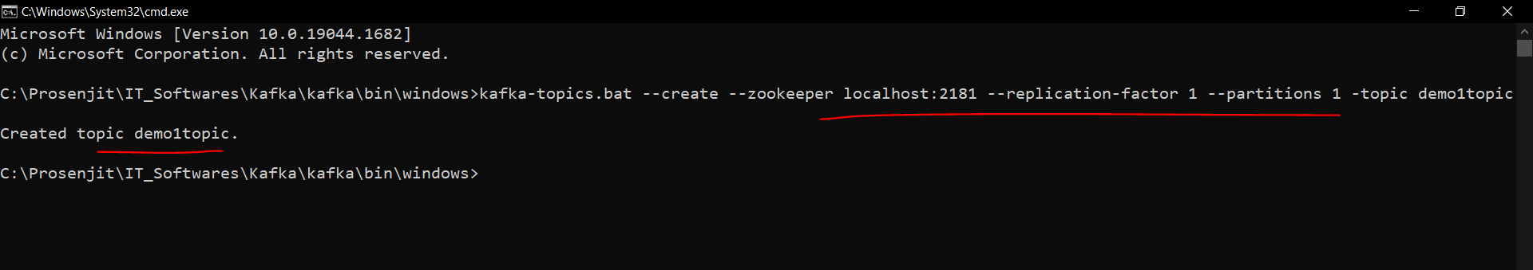

To check all the topics:

kafka-topics.bat --zookeeper localhost:2181 –list

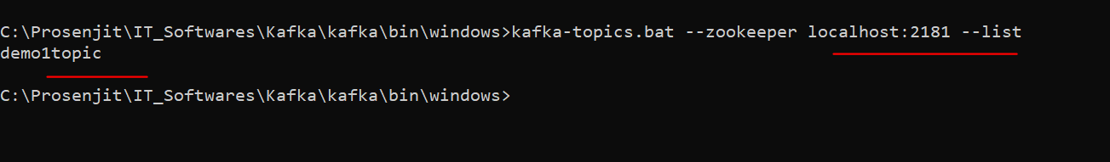

Now create Spring boot project:

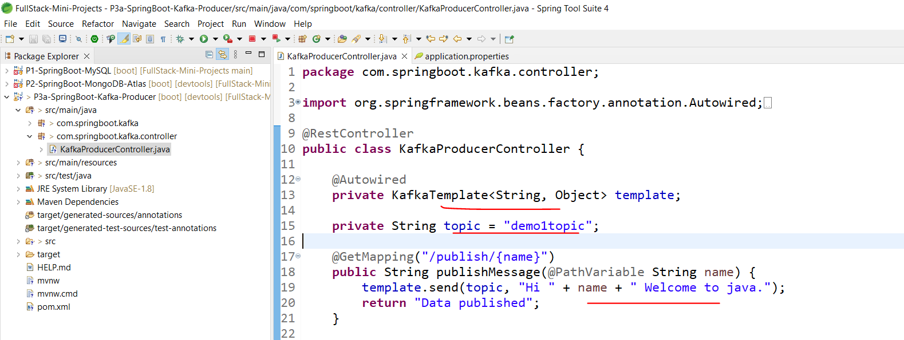

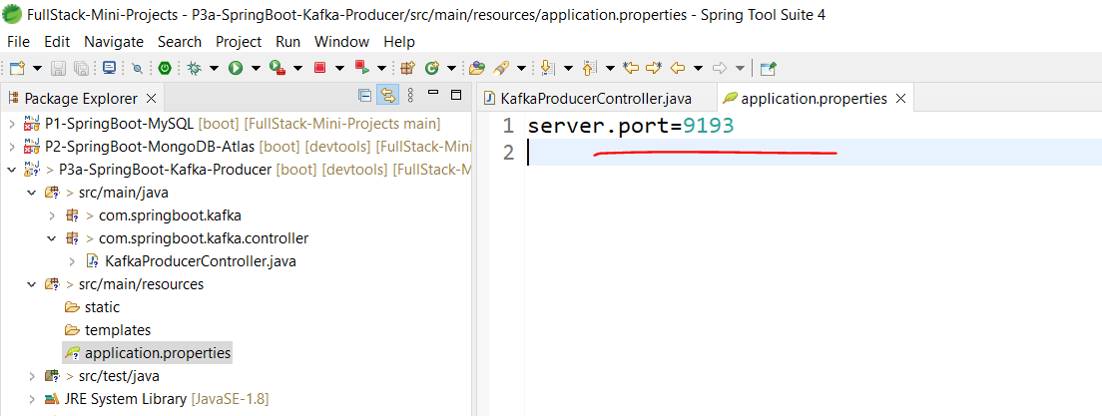

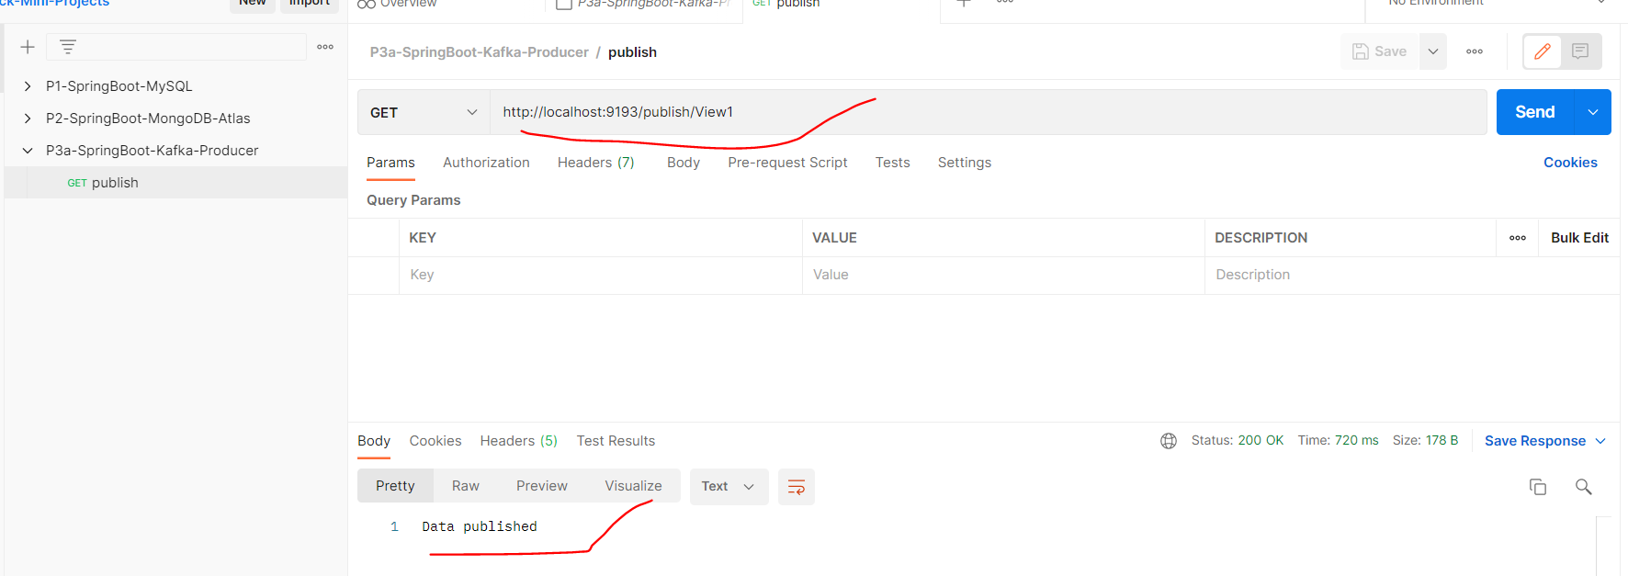

To consume this Topic:

kafka-console-consumer.bat --bootstrap-server localhost:9092 --topic demo1topic

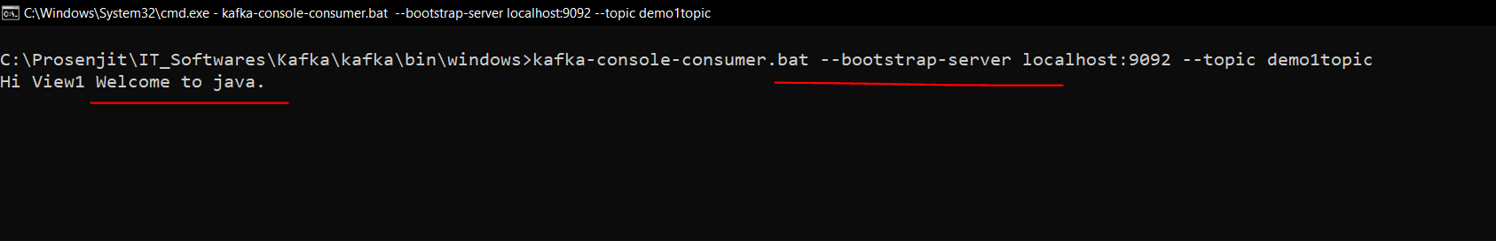

Now with a complex object:

Add a new object:

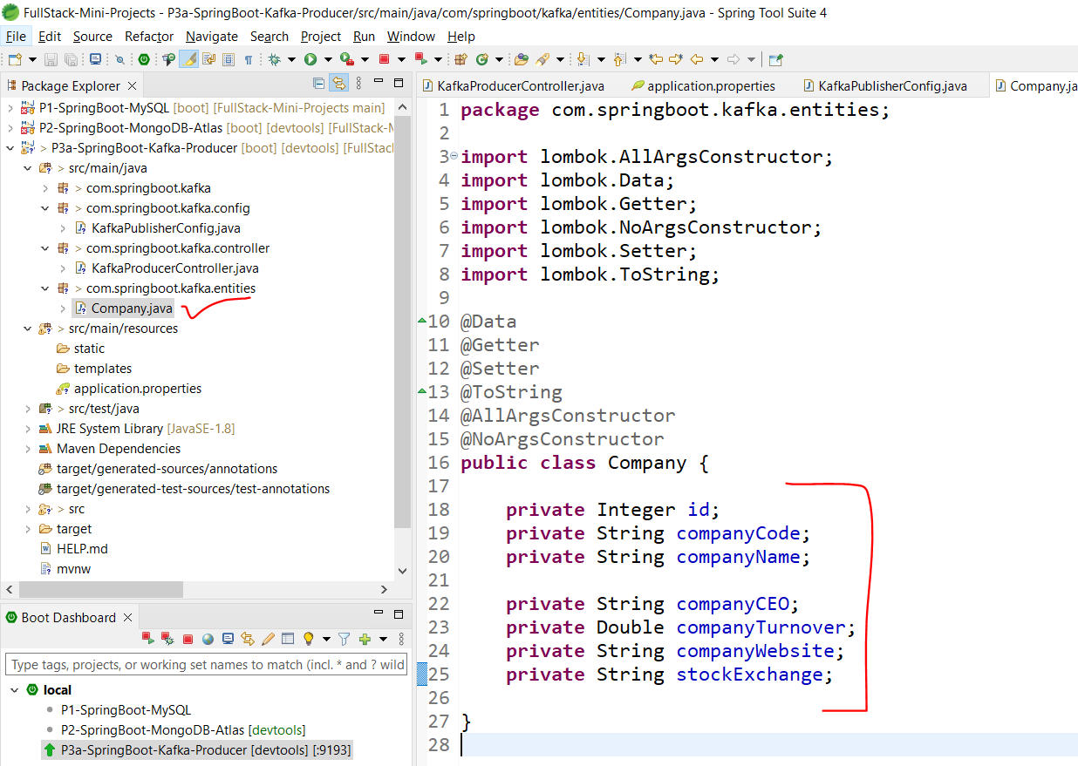

Add new file:

